**ChatGPT as an Assistant for Statistical Analysis in R, SPSS, and Stata: Practical Cases and Recommendations for Executing, Reporting, and Interpreting Data**

Objectives/RQs/Hypotheses:

* Analyze the possibilities of ChatGPT for data analysis across all stages
  + Starting from hypothesis/research questions:
    - define the statistical tests required
    - running of tests
    - interpretation and writing results, including graphical representation
  + Test a variety of statistical techniques from basic stats to advanced.
  + All output and interpretation in APA format.

Data:

* Use survey data and initial hypotheses.
  + Separation: One case study for each data+hypothesys/ses clearly defined, e.g.
    - Case study 1: data + hypothesys
    - Case study 2: same data + 2 hypotheses
* [May be bate]: Use data from public repositories/sources
* Selecting good case studies is IMPORTANT.

Method:

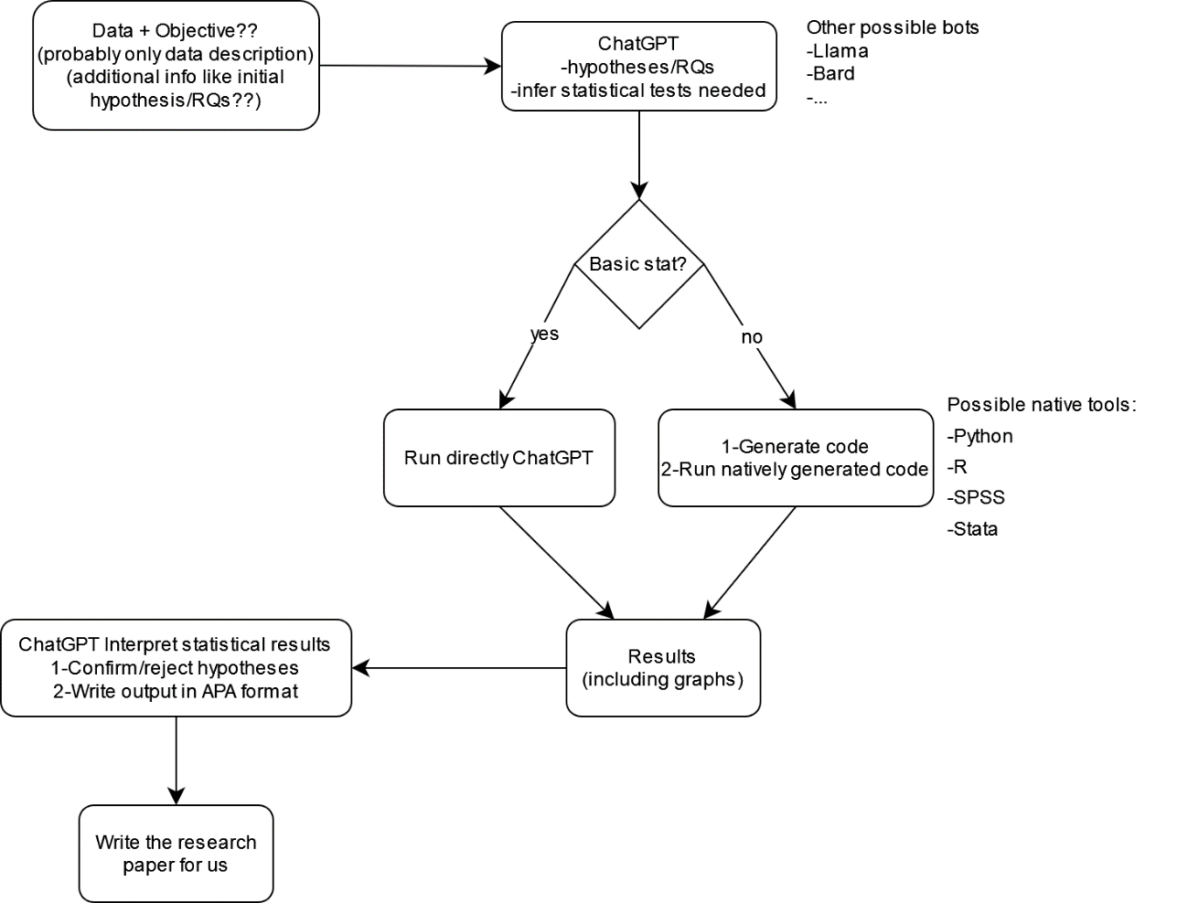

Stats (prioritized):

1) Data Management & Descriptives

* Descriptive statistics
* Constructs (computing)
* Normality test

2) Statistical Test:

2.1. Reliability

* Cronbach Alpha (item analysis)
* Omega [3]
* Spearman-Brown coefficient

2.2. Predictions

* Hierarchical multiple regression

2.3. Asssociations

* Correlations

2.4. Differences between Groups

* t-test
* ANOVA

2.5. Conditions & Mechanisms

* Mediation
* Moderation

3) Charts and Graphs

* Simple bar chats (experiments)
* Clustered bar chats (experiments)
* Moderation graph

Expected results:

* Detailed protocol for ChatGPT-assisted data analysis for the different stages, at least:
  + ChatGPT for assisting in statistical analysis
  + ChatGPT for interpretation and reporting of statistical results
* Case studies with protocol & output
* [Optional] Analysis of stages in which ChatGPT can assist or not assist. May include other stages/substages like ChatGPT for selecting tests. May be classified by level of assistance per stage (check [1])

Initial references:

[1] Evaluating ChatGPT-4.0’s data analytic proficiency in epidemiological studies: A comparative analysis with SAS, SPSS, and R <https://www.ncbi.nlm.nih.gov/pmc/articles/PMC10978058/>

[2] ChatGPT and Academic Research: A Review and Recommendations Based on Practical Examples <https://papers.ssrn.com/sol3/papers.cfm?abstract_id=4407462>

[3] Use Omega Rather than Cronbach’s Alpha for Estimating Reliability. <https://www.tandfonline.com/doi/pdf/10.1080/19312458.2020.1718629>